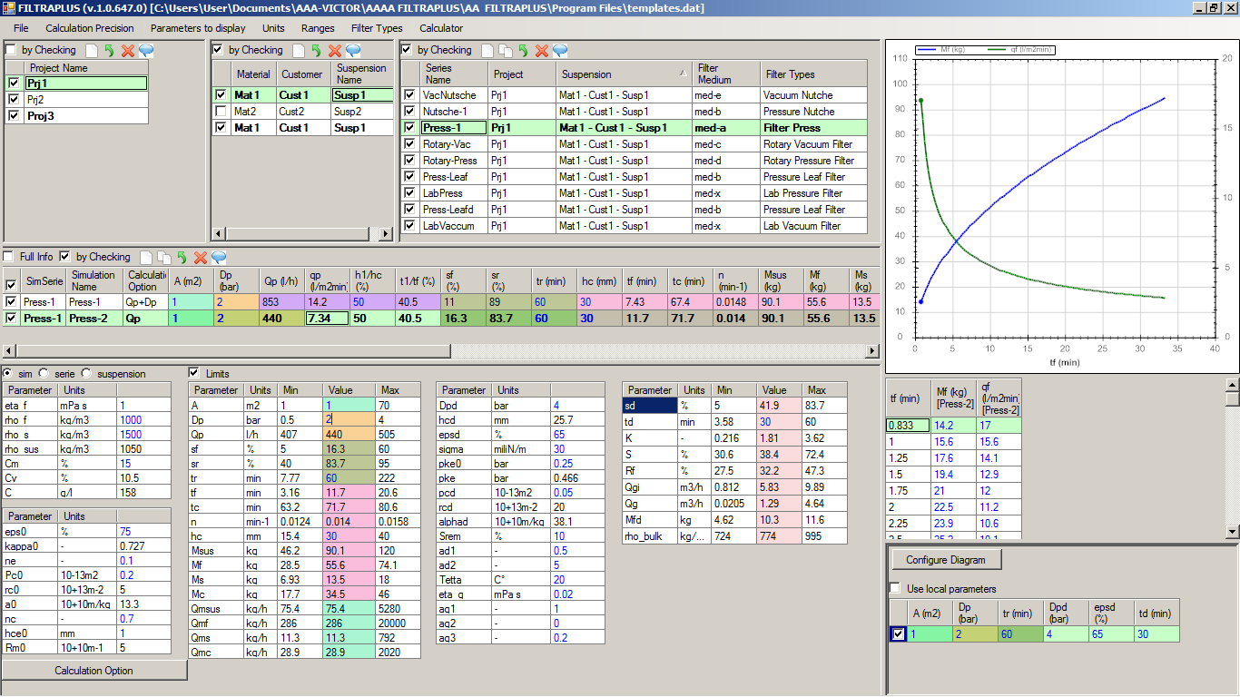
Problem with limits for the option Qp=const. If I have the Dp as input (see above) then I have not any problem. But if I have the Qp as input then I get a problem with limits (see below).
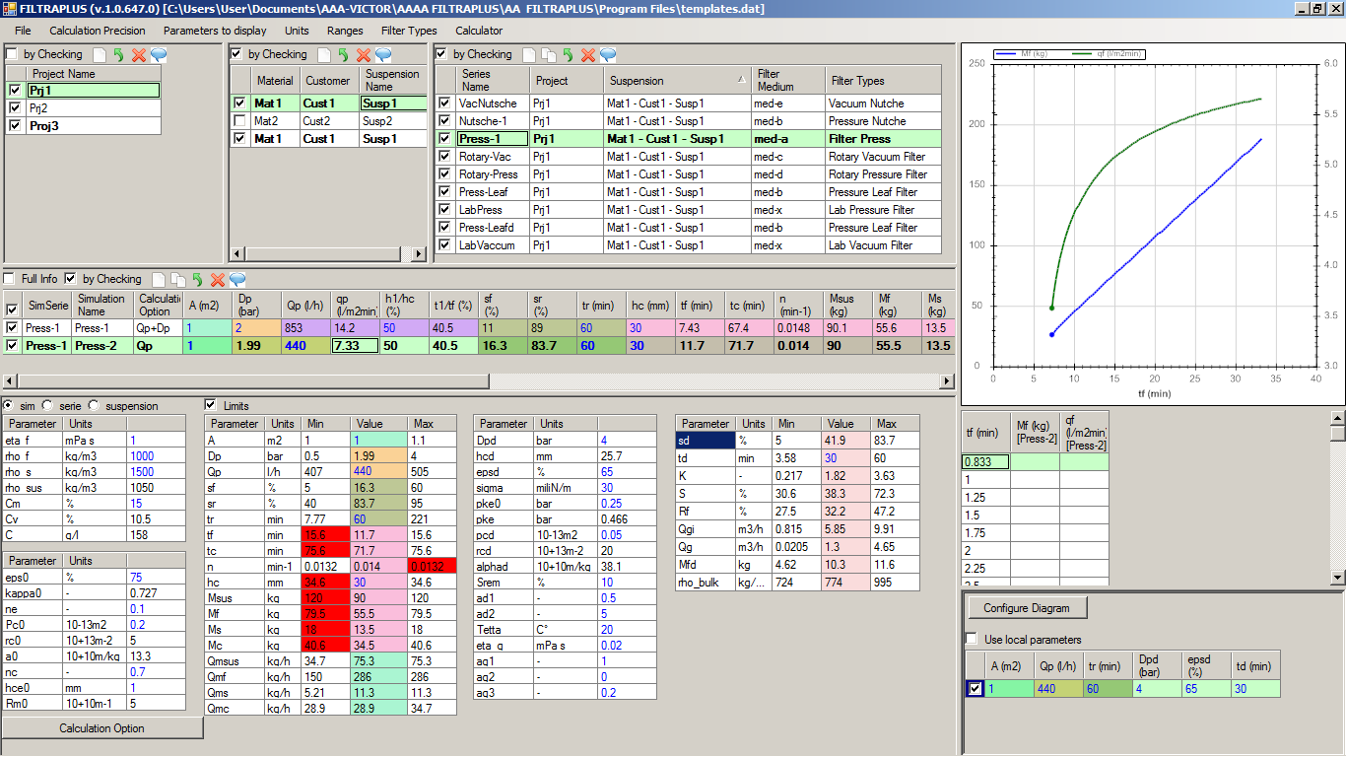
What is the reason for this problem? Maybe because we have not included Qp in the Ranges – List?

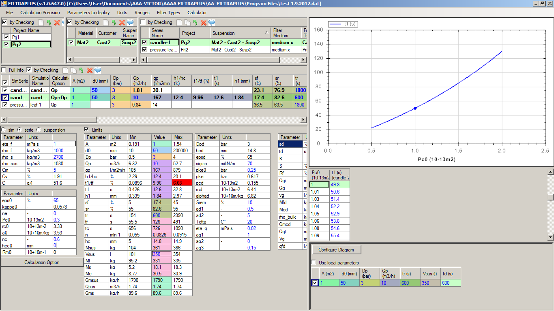
What is the reason that we have there a red number? All input parameters are within the limits and we should not have any problem.
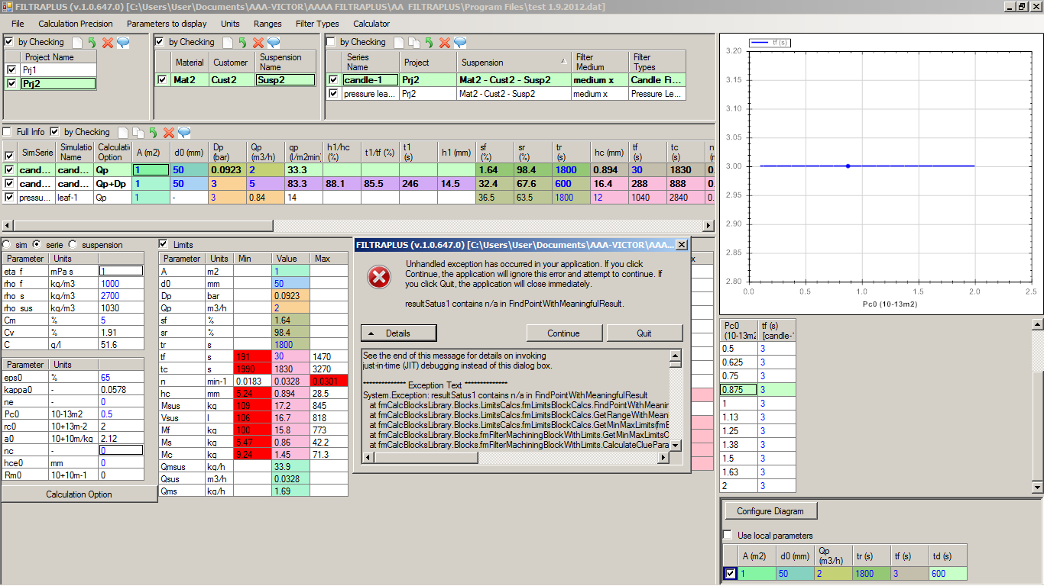
I was entering tf for Qp as input and I got the above error.

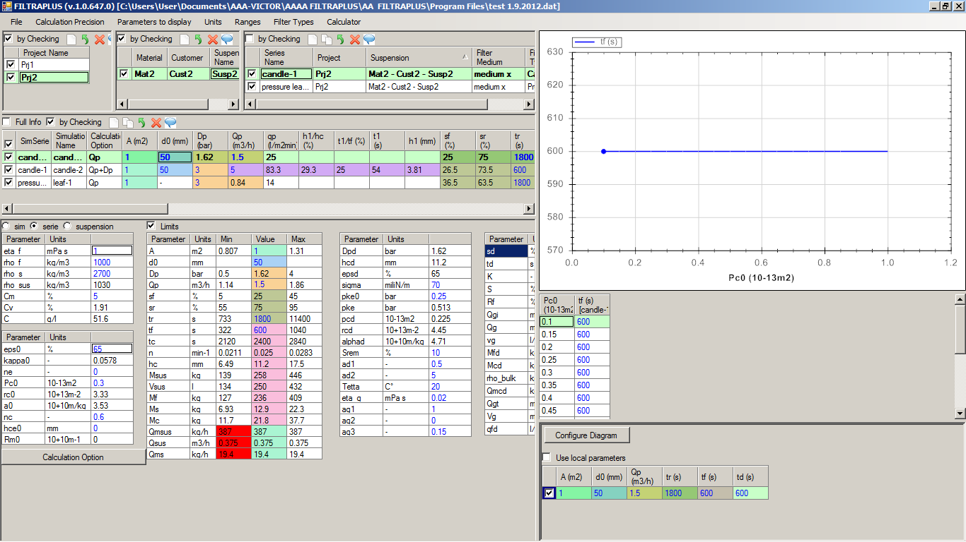
There are problems with the limits there when we have Qp as input and not Dp!
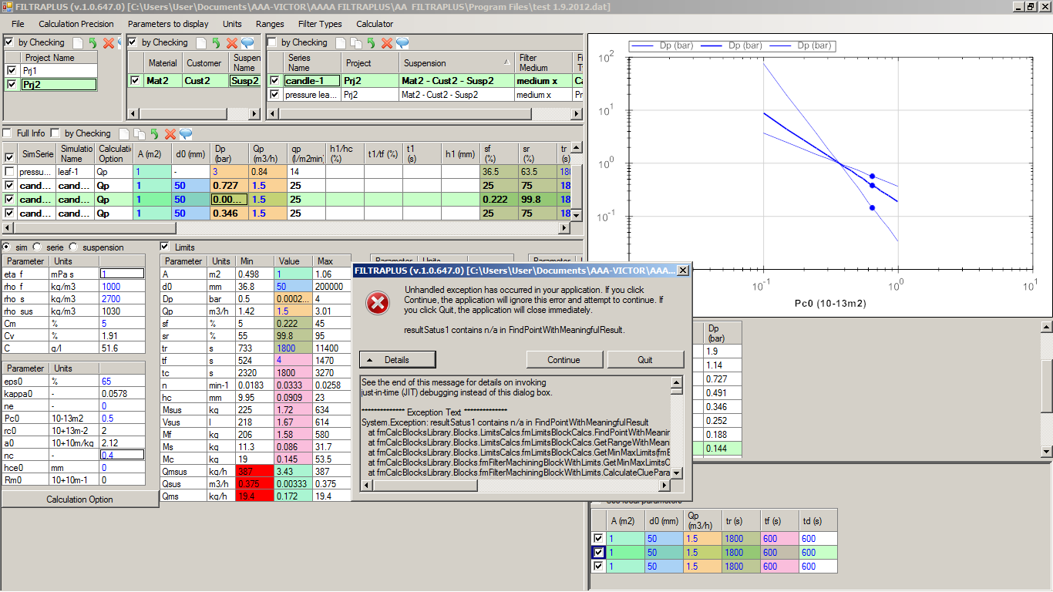
Again I get an error when trying to enter a new value for tf!

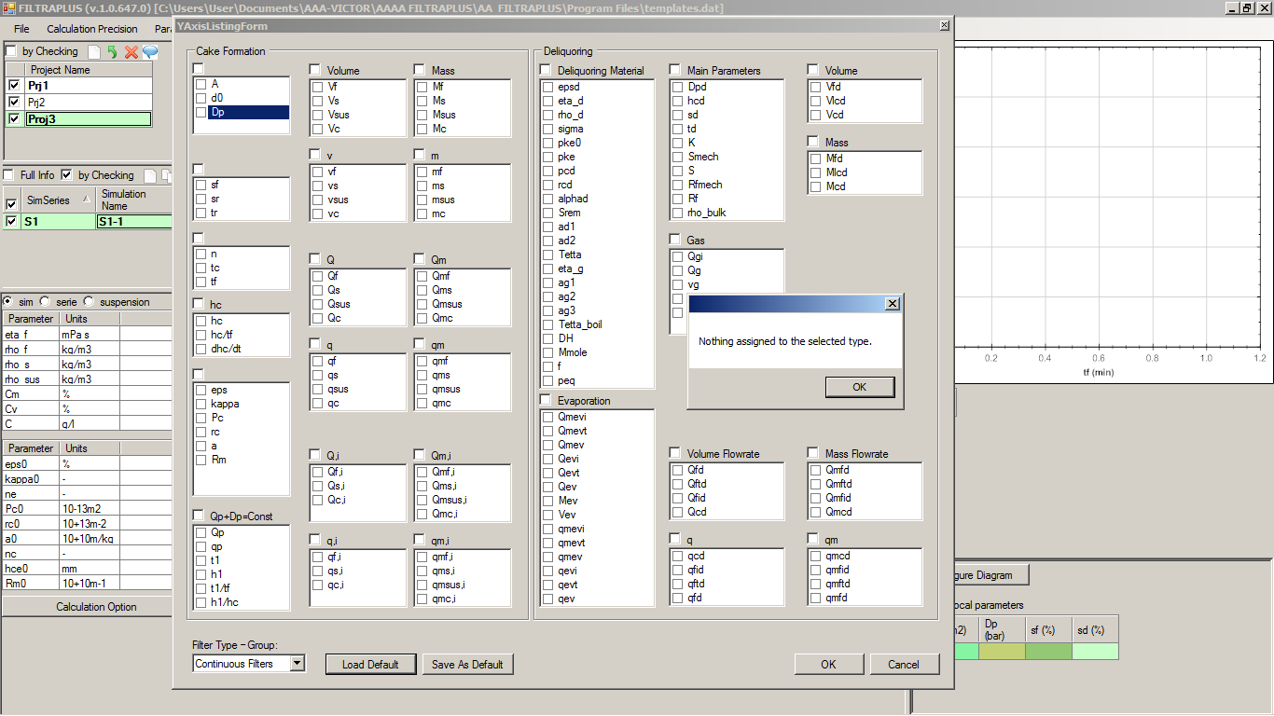
Why when creating a new Project-new suspension – new series we do not have any default selected parameters to show?

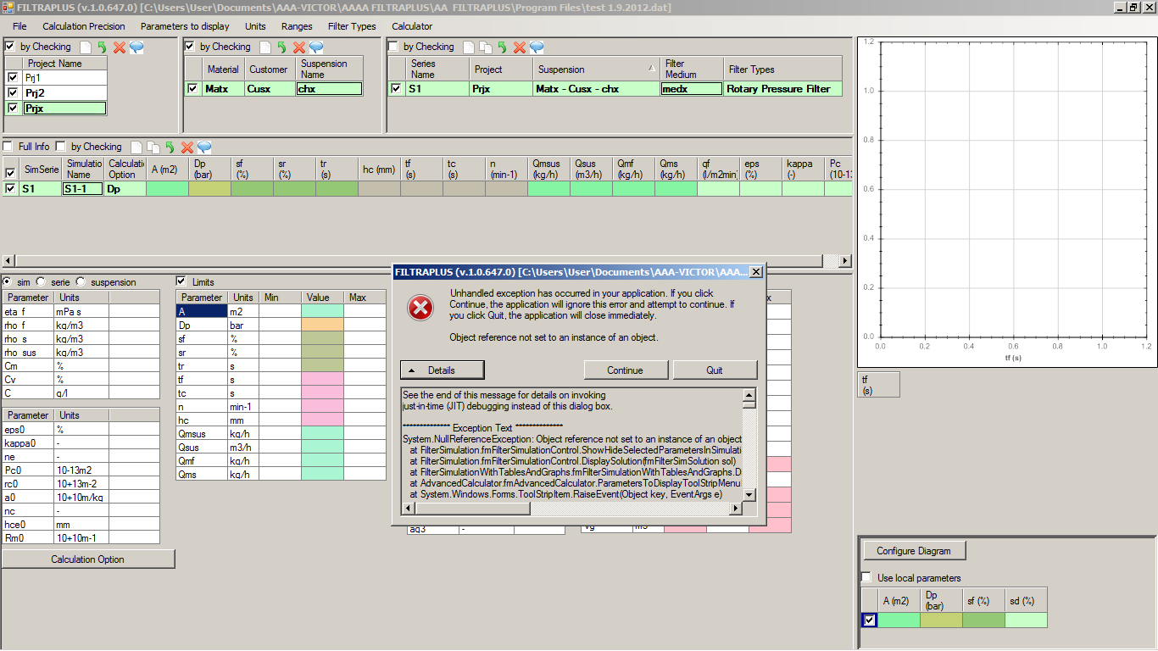
I had selected in the show/hide window the parameters for the new series and then OK and I get an error.

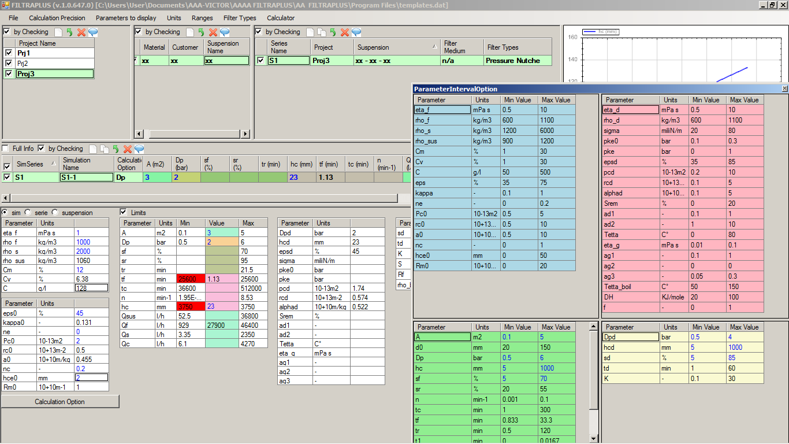
The limits concept is not working correctly when creating new series.

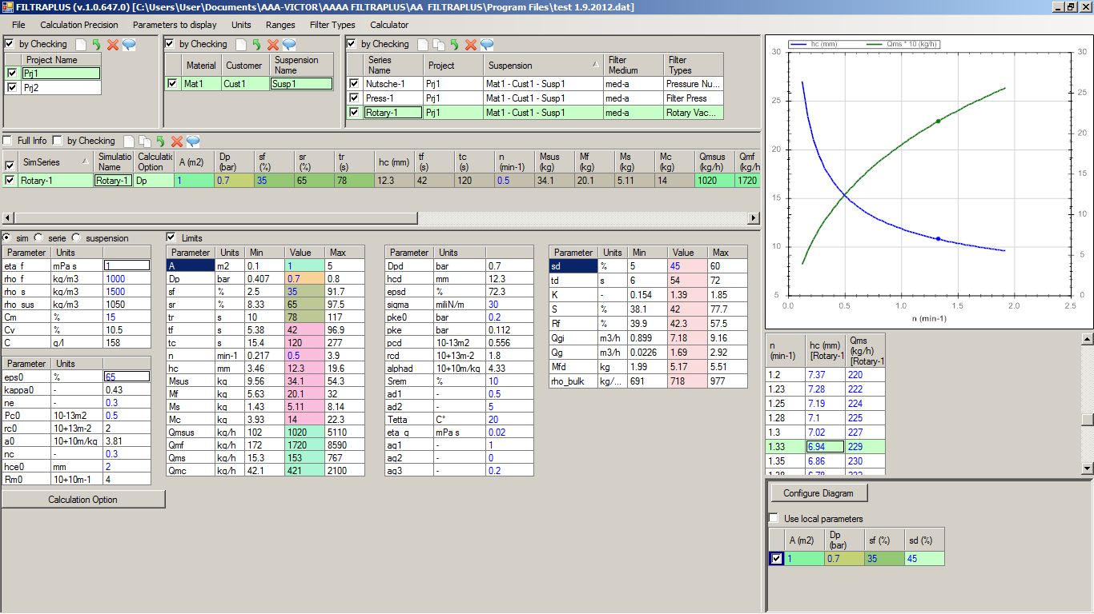
We have no chance to identify what is y1 and what is y2-axis

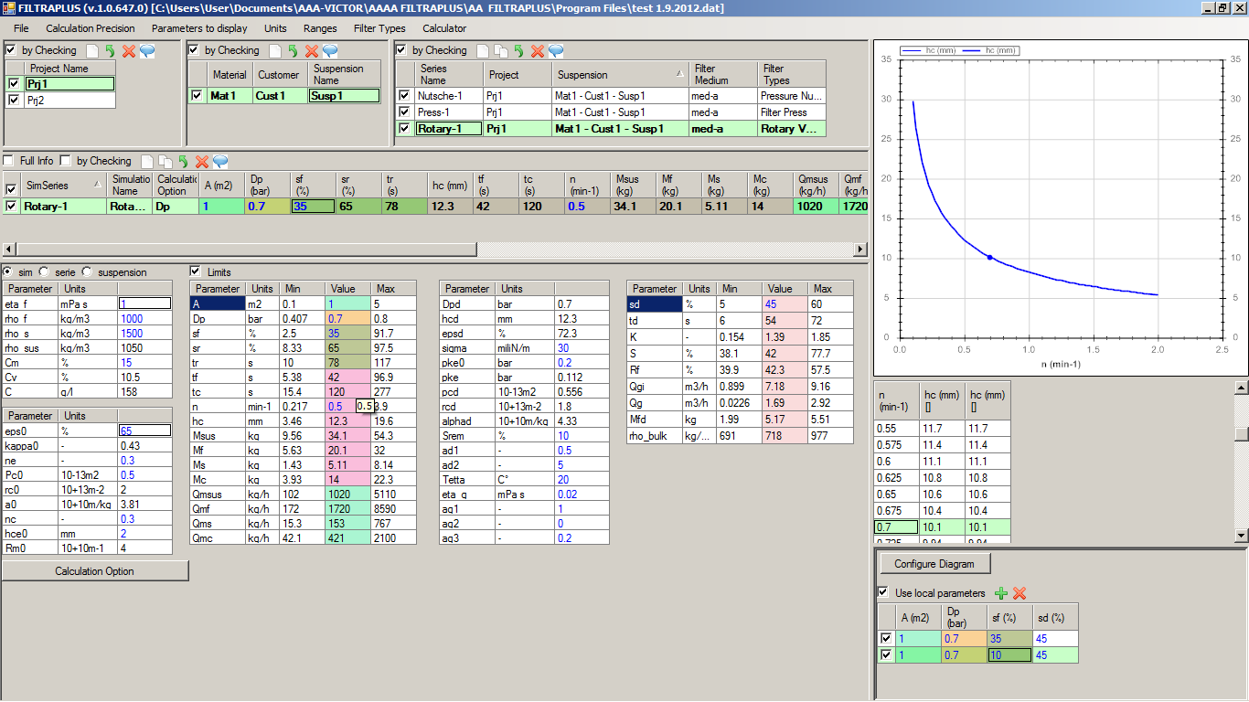It is an error that changing the sf we so not get 2 curves.

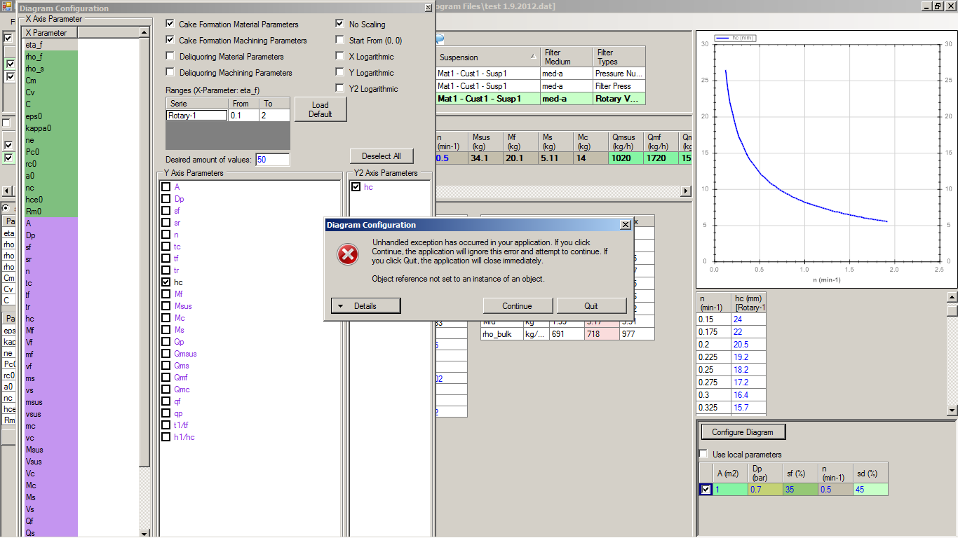
Having first the option “Use local parameters” and then selecting “NOT use local parameters” and in the diagram config

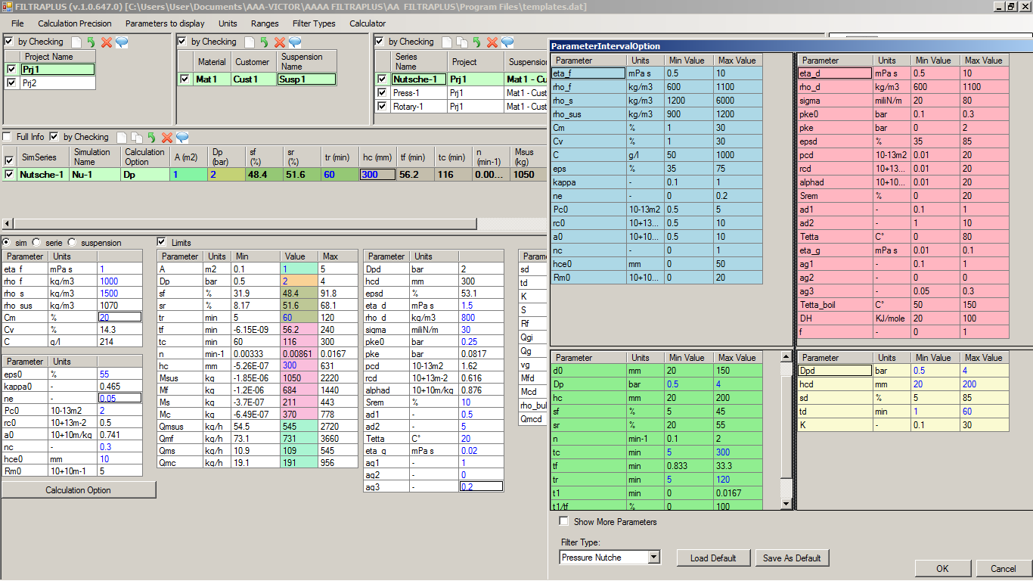
What is the reason that we have such values as minimal values?

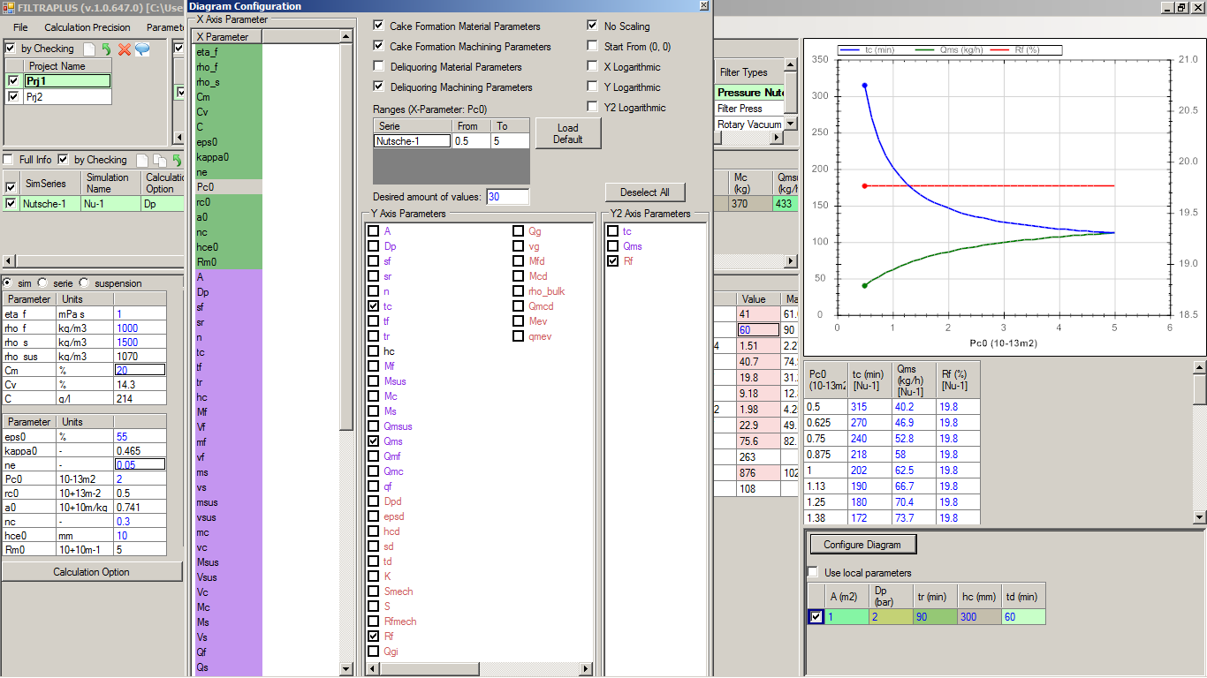
That is not correct with Rf-dependency. The Pc0 influences the Rf because pc0 influences pcd and pcd influences K, which influences S and then of course Rf.

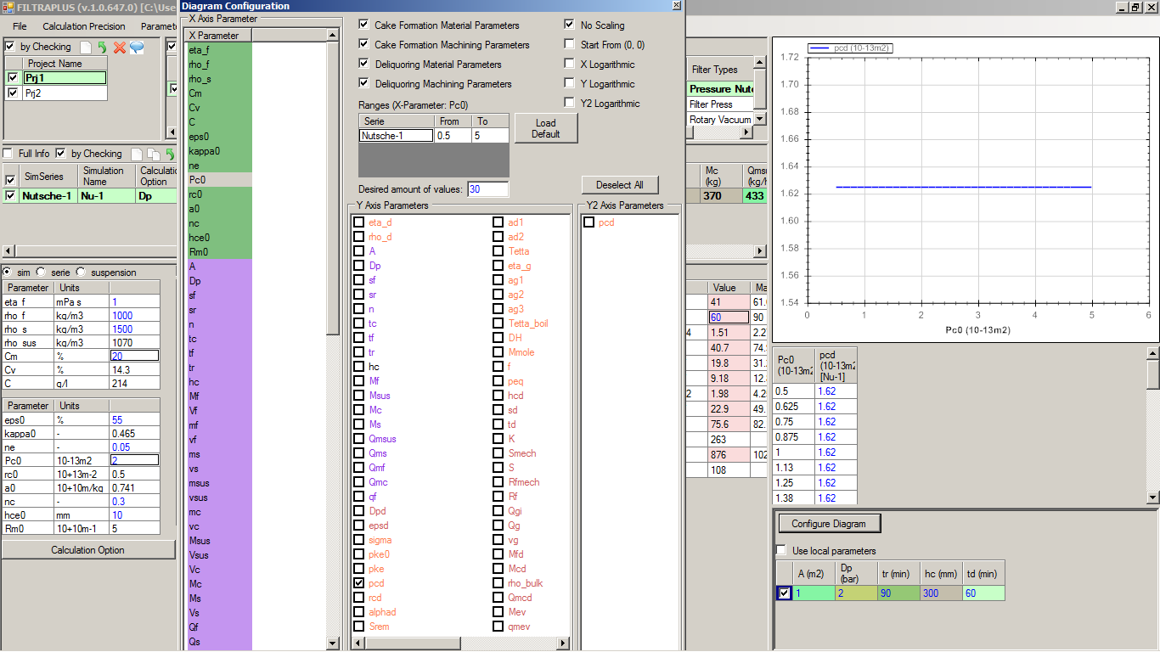
That is the problem. The pcd is constant. But this is not correct. The higher the pc0 the hiogher pcd!

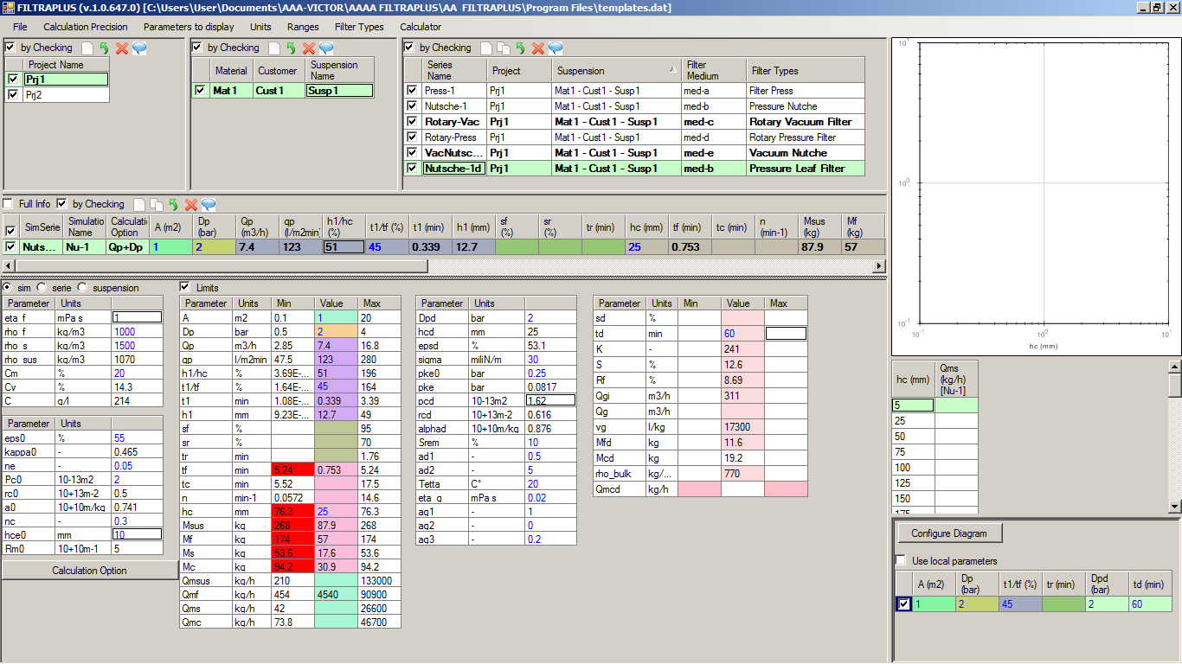
The ranges for the option Qp+Dp=const are not working correctly.

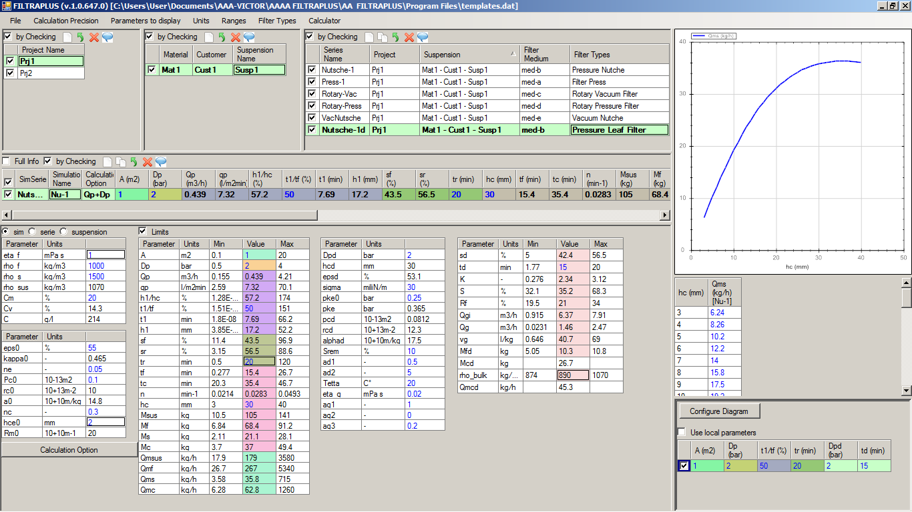
For the deliquoring parameters which are i/c should be one after the other. For example the Mcd should be displayed after the rho_bulk.

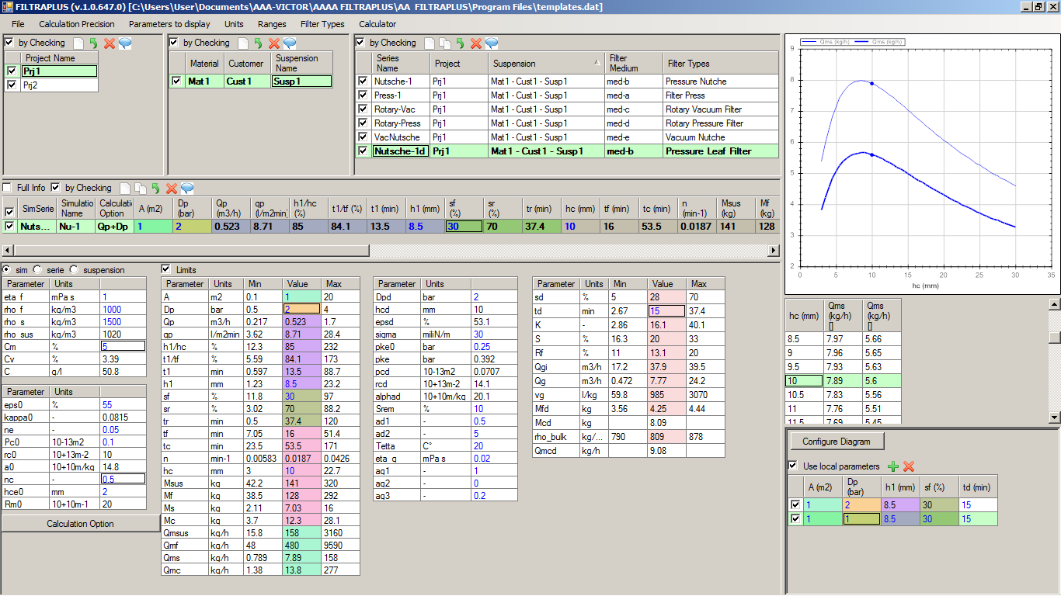
Also for “Use local parameters” option we should distinguish the active simulation.

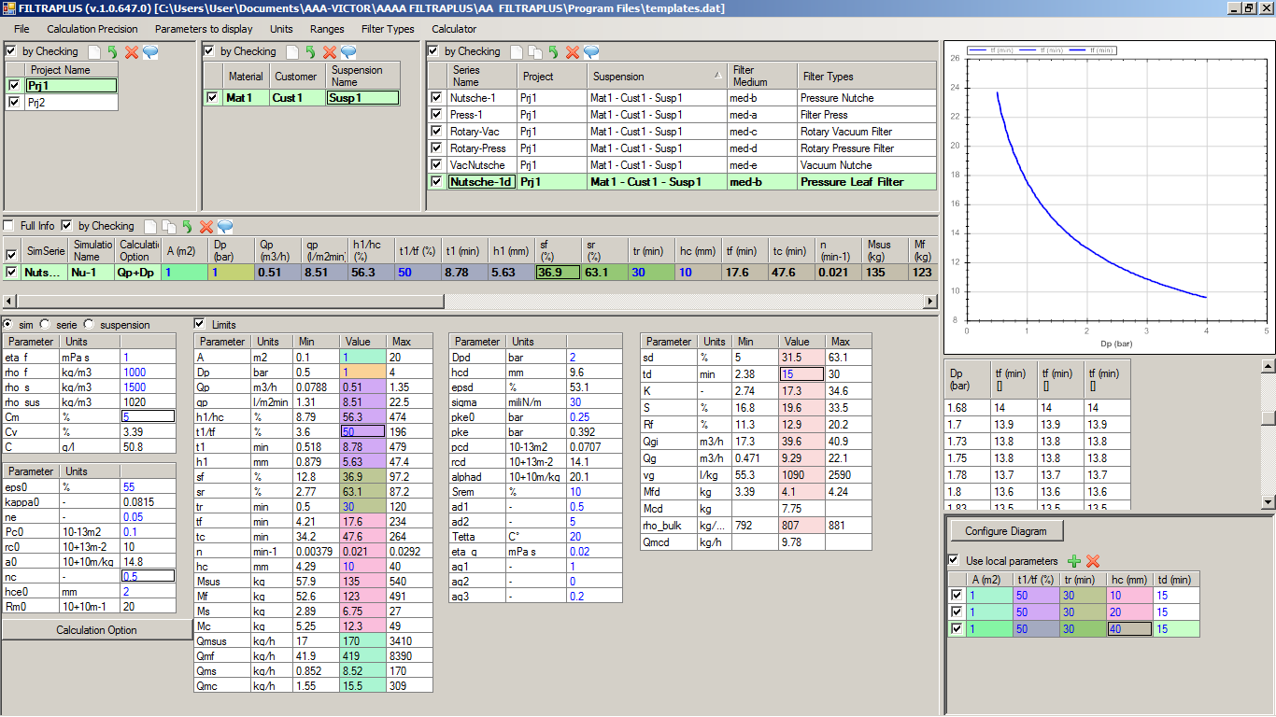
It is an error that for different hc-values we have the same curve, that means no influence on tf. That is wrong! (see NOT local parameters results below).

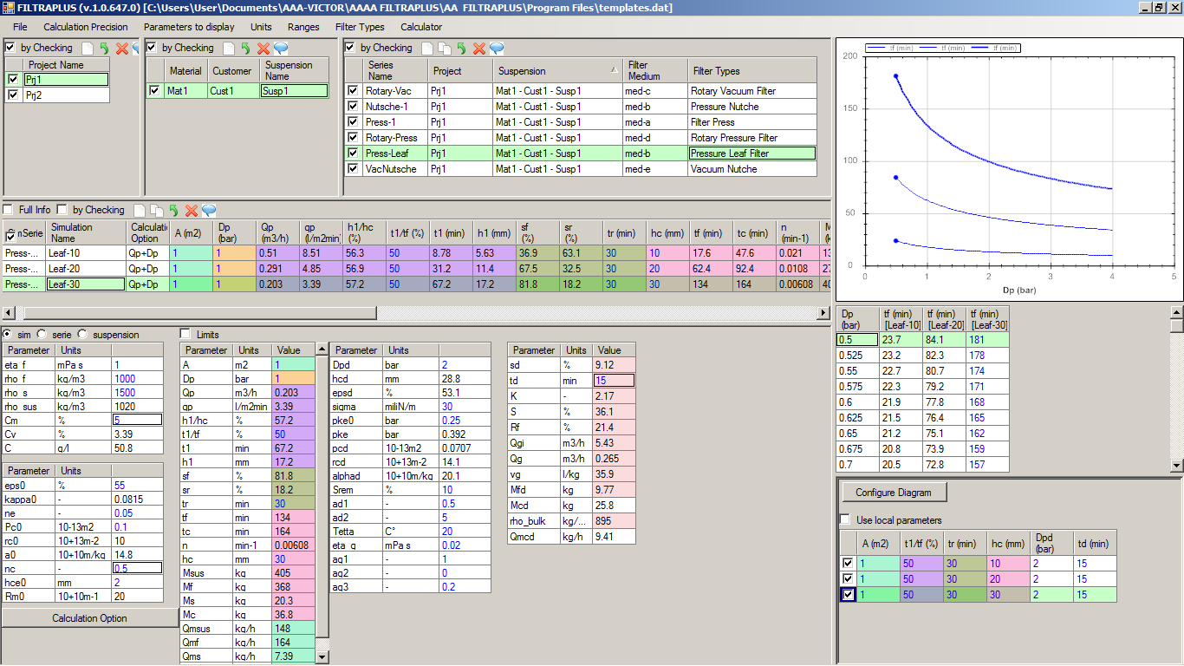
These are correct curves.

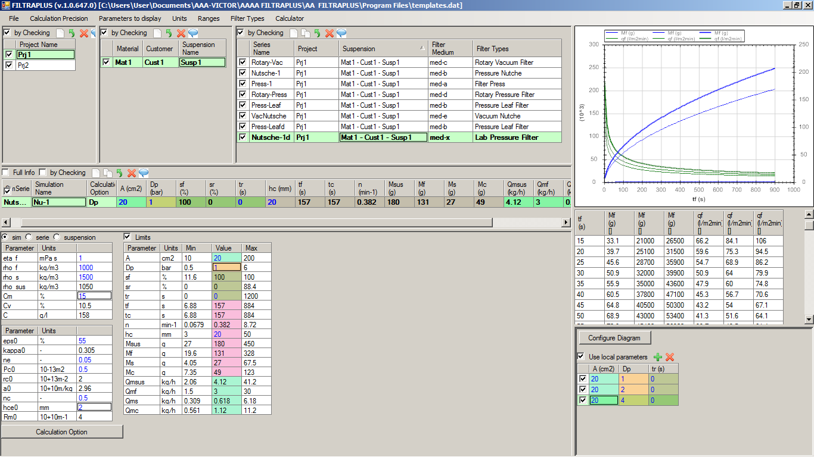
The “Use local parameters” option is not working correctly! Although I had entered for the 2 created simulations A=20 cm2 (same as the mother simulation) still we have not a refreshing for the Mf. It calculates with a much bigger area which was existing in the memory!

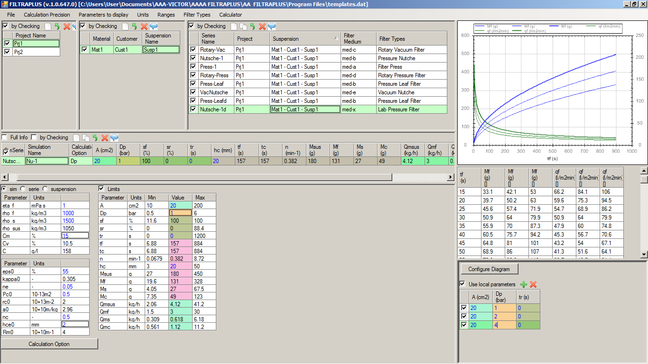
After deleting the created simulations and creating them again then we get correct results.

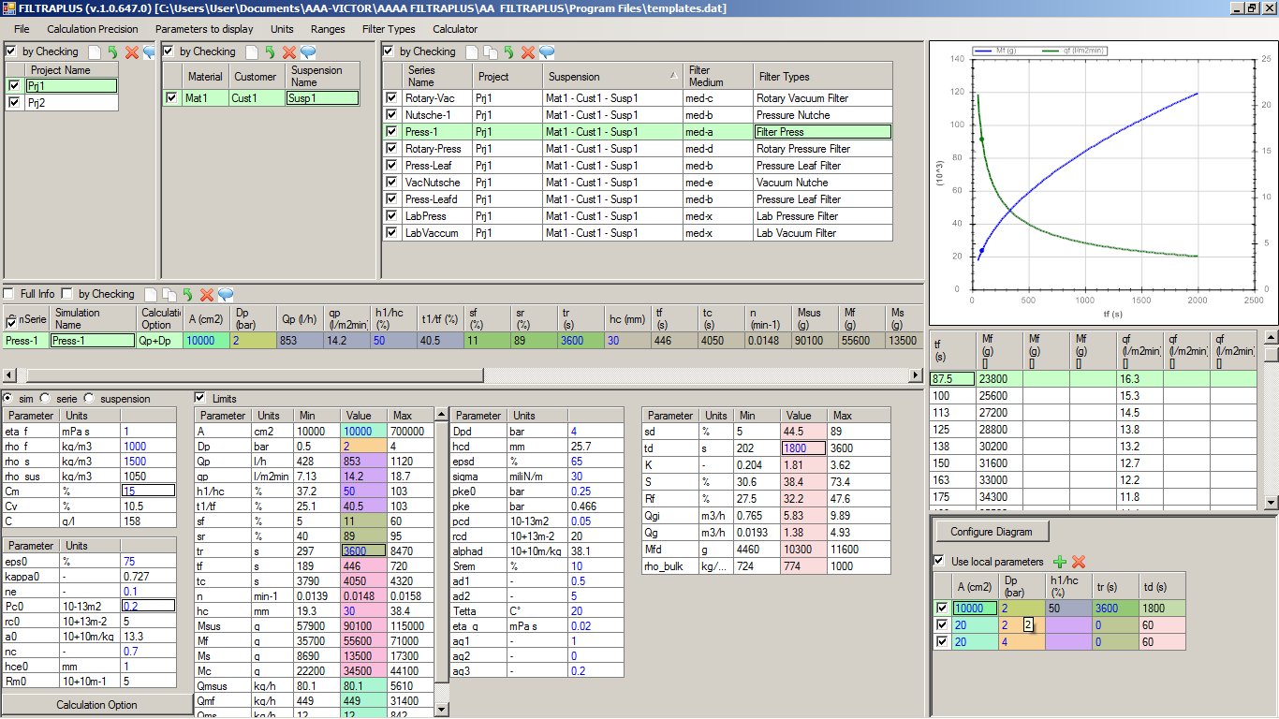
That is a wrong concept.

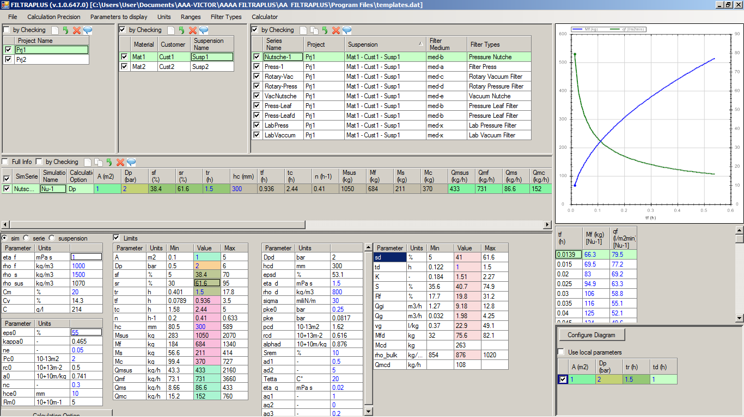
We need definetely the possibility to duplicate also a suspension and also to duplicate a project. That is very important!

When duplicating a suspension we need to decide “Only selected Series” or “All checked series”
When duplicate a Project we have to decide “Only selected Suspension” or “All Checked Suspensions”.

If duplicating a suspension then we should have at the end of the names for material-customer-charge the endings “d” for duplication or copy.

If duplicating a project we should have for the duplicated project name the ending “d” as indication for a duplication!

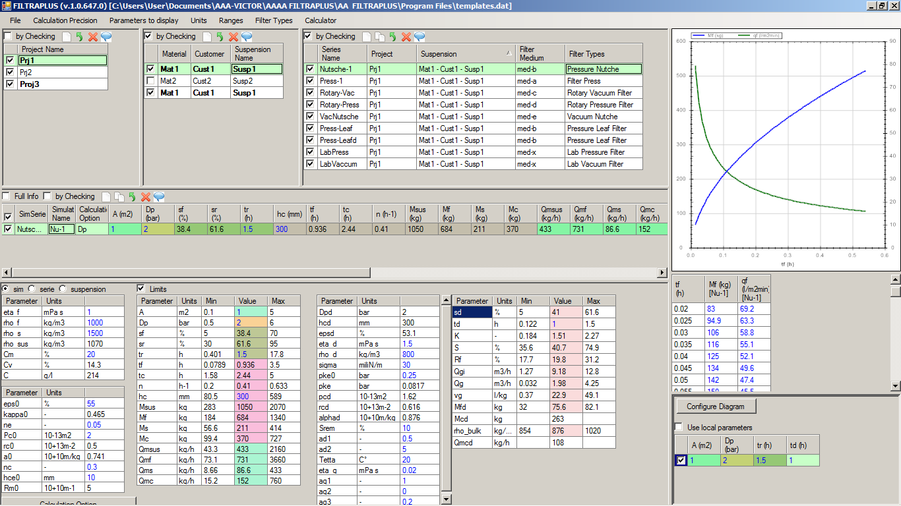
The Filter Types command should appear also there!

We should add additional Filter type names. In the following we display all Filter types, which we should support:

- -Vacuum Drum Filter
- -Vacuum Disk Filter
- -Vacuum Pan Filter
- -Vacuum Belt Filter

- -Rotary Pressure Filter

- -Vacuum Nutsche
- -Pressure Nutsche
- -Pneuma Press

- -Pressure Leaf Filter
- -Candle Filter

- -Filter Press
- -Filter Press Automat

- -Lab Vacuum Filter
- -Lab Pressure Filter

We should ephasize the groups with different colors for an easier selection.

The following filters are Pressure filters:
5, 7, 8, 9, 10, 11, 12, 14
and the others are vacuum filters. This is important for the calculation of the Gas flow rate!

